**c**

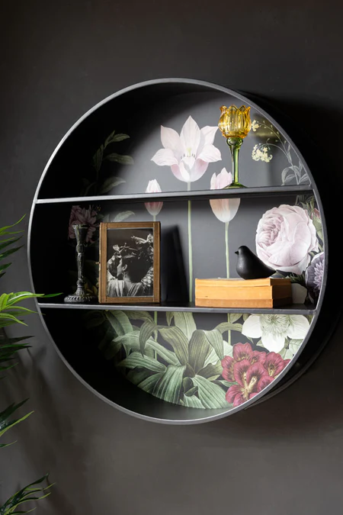 Floral and black metal display floating wall shelves combine elegance and functionality, creating a striking visual centrepiece for any room. Featuring a sturdy black metal frame adorned with intricate floral patterns, these shelves exude a blend of modern sophistication and vintage charm. Perfect for showcasing decorative pieces, books, or small plants, they provide both practical storage and a decorative statement. Their versatile design makes them a great fit for various interior styles, from industrial to bohemian, enhancing the ambiance of any space.